Worksheet 3.4

Fossils
Answers

Archaeopteryx
1. The photo below shows the 150 million year old fossilised remains of an Archaeopteryx.
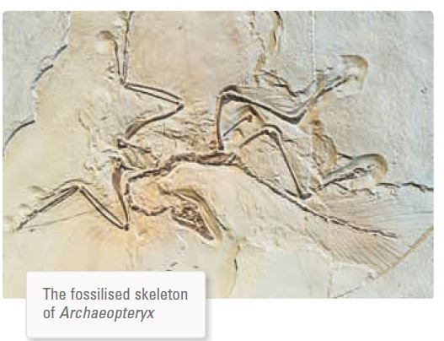
Photo: In Green / Shutterstock.com
(a) Identify the features that survived the fossilisation process.
Bones and feathers

(b) Explain why these features survived whereas others did not.
They are hard and not readily broken down and are least subject to decay.

(c) Explain the scientific importance of this fossil.
The fossil is an intermediate form between true birds and dinosaurs. It thus provides evidence of evolution.

Worksheet 3.4

Page 2

Ancient leaves
2. The photo below shows the remains of ancient leaves that have been fossilised.
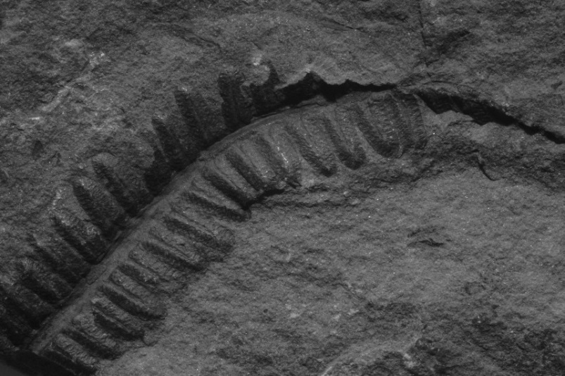
Photo: Baciu / Shutterstock.com
(a) Classify this type of fossil.
Carbon imprint

(b) Explain how this fossilisation process has occurred.
Following death, ancient plants can leave carbon imprint fossils when they are covered by sediment before they decay. The leaf tissue loses moisture and degrades and eventually carbonises due to the pressure and heat generated over geological time.

Insects
3. The photo below shows a fossilised insect.
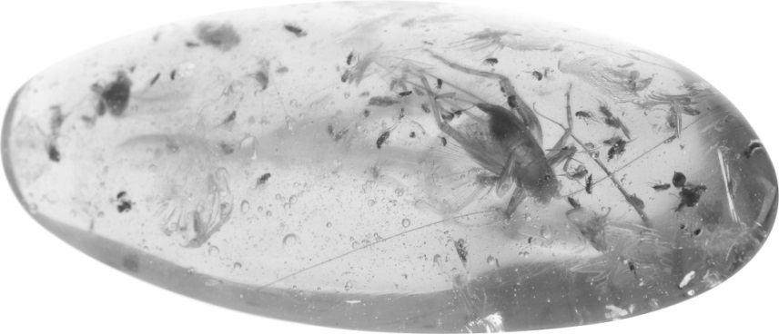
Photo: Roy Palmer / Shutterstock.com
(a) Classify this type of fossil.
Unaltered hard parts — whole organism/amber fossil

(b) Describe how the body of this insect was preserved.
The insect was trapped and engulfed by tree sap, which hardened around it and prevented decay. This solidified sap fell from the tree and became covered with sediment and fossilisation occurred. The material is called amber.

